SIMATS ENGINEERING
ASSESSMENT TOOL 1

COURSE NAME: Database Management Systems
COURSE CODE: CSA05
NAME: A. Suraj varma
Reg.No: 192525339

COURSE OUTCOME COVERED

CO4: Design database solutions incorporating file organization, indexing, and hashing techniques to optimize data storage and retrieval efficiency. (BL3, BL4)

Activity Tool : Code Challenge (High)
Assessment Tool Weightage: 35%

Dr

QUESTIONS Total Marks: 50
Q.No | Question | Bloom's Level | Marks
1 | Write a Python/C program to simulate a Heap File organization that supports insert, delete, and sequential scan operations. | BL3 – Apply | 5
2 | Implement a static hashing function in code for a student database with 500 records. Handle collisions using chaining. | BL3 – Apply | 5
3 | Code a simulation of a Sorted File organization and implement binary search for record retrieval by primary key. | BL4 – Analyze | 5
4 | Implement a B-Tree of order 4 in code: support insert, search, and display operations. Insert keys: 10, 20, 5, 6, 12, 30, 7, 17. | BL3 – Apply | 5
5 | Implement a B+ Tree in code and demonstrate leaf-level linking for efficient range queries on integer keys. | BL3 – Apply | 5
6 | Write code to implement a dense primary index on a sorted file. Support search by index key and display the index table. | BL4 – Analyze | 5
7 | Implement extendible hashing in code. Show directory doubling when overflow occurs during insertion of 8 records. | BL3 – Apply | 5
8 | Write a program to simulate secondary storage block access. Calculate the number of I/O operations for sequential vs. indexed retrieval. | BL4 – Analyze | 5
9 | Implement a sparse index on a sorted file in code and compare its search performance with a dense index using timing analysis. | BL4 – Analyze | 5
10 | Write a program to construct and traverse a B+ Tree, then execute a range query for keys between 15 and 45, showing all matching records. | BL4 – Analyze | 5

Code of Conduct:

I A. Suraj varma (192525339) (Name / Reg No) certify that this submission is my original work and that I have adhered to the guidelines specified for this assessment.
I understand that any violation of academic integrity rules will result in disciplinary action.
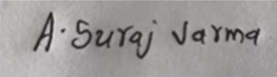
Signature of the student:

RUBRICS FOR CALCULATION:

Criteria | Weightage | Level 4 (Exemplary) | Level 3 (Proficient) | Level 2 (Developing) | Level 1 (Beginning)
Problem Understanding | 20% | Clearly understands problem constraints, edge cases, and competitive requirements | Understands problem with minor gaps in constraints | Partial understanding; misses key constraints | Misinterprets problem or constraints
Algorithm | 25% | Selects optimal algorithm with best time and space complexity for competitive constraints | Uses efficient algorithm with minor scope for improvement | Uses basic/inefficient approach | No clear algorithmic approach
Code Implementation | 20% | Writes correct, efficient, and clean code that passes all constraints | Code works with minor errors or inefficiencies | Partially correct code; fails for some cases | Code does not execute or gives incorrect results
Competitive Performance | 20% | Solves problem within time limits and handles large inputs effectively | Solves within acceptable time with minor delays | Struggles with time limits or larger inputs | Unable to solve within time constraints
Test Case Handling | 15% | Handles all test cases including edge and hidden cases | Handles most test cases | Misses important edge cases | Fails on multiple test cases

Q1. Heap File Organization
Question: Write a Python/C program to simulate a Heap File organization that supports insert, delete, and sequential scan operations.
Answer
# Heap File Organization
# Supports Insert, Delete and Sequential Scan

CODE:

class HeapFile:
def __init__(self):
self.records = []

# Insert a record
def insert(self, record):
self.records.append(record)
print("Record inserted:", record)

# Delete a record using ID
def delete(self, record_id):
for record in self.records:
if record["id"] == record_id:
self.records.remove(record)
print("Record deleted:", record)
return

print("Record not found.")

# Sequential scan
def sequential_scan(self):
print("\nSequential Scan:")

if not self.records:
print("No records available.")
return

for record in self.records:
print(record)

# Create heap file
heap = HeapFile()

# Insert records
heap.insert({"id": 101, "name": "Arun"})
heap.insert({"id": 102, "name": "Rahul"})
heap.insert({"id": 103, "name": "Kiran"})

# Display all records
heap.sequential_scan()

# Delete record
heap.delete(102)

# Display records after deletion
heap.sequential_scan()

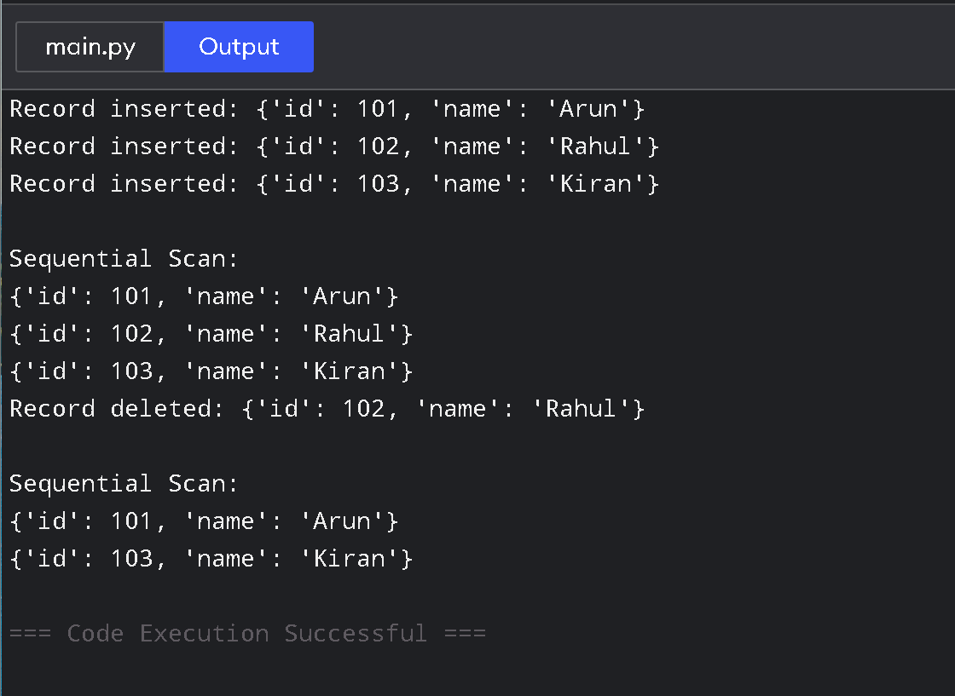
Output:

How it works
- Insert: Adds the record at the end of the file.
- Delete: Searches sequentially and removes the matching record.
- Sequential scan: Reads every record one by one.
- Heap file does not maintain records in sorted order.
Complexity:
- Insert: O(1) average
- Delete: O(n)
- Sequential scan: O(n)

Q2. Static Hashing with Chaining
Question: Implement a static hashing function for a student database with 500 records and handle collisions using chaining.
Answer
# Static Hashing with Chaining

class StaticHashTable:
def __init__(self, size=10):
self.size = size
self.table = [[] for _ in range(size)]

# Hash function
def hash_function(self, student_id):
return student_id % self.size

# Insert student
def insert(self, student_id, name):
index = self.hash_function(student_id)
self.table[index].append((student_id, name))

# Search student
def search(self, student_id):
index = self.hash_function(student_id)

for record in self.table[index]:
if record[0] == student_id:
return record

return None

# Display hash table
def display(self):
print("\nHash Table:")

for i in range(self.size):
print(i, "->", self.table[i])

# Create hash table
hash_table = StaticHashTable()

# Insert sample student records
for i in range(1, 501):
hash_table.insert(i, "Student" + str(i))

# Display table
hash_table.display()

# Search a student
student = hash_table.search(205)

if student:
print("\nStudent found:", student)
else:
print("\nStudent not found.")

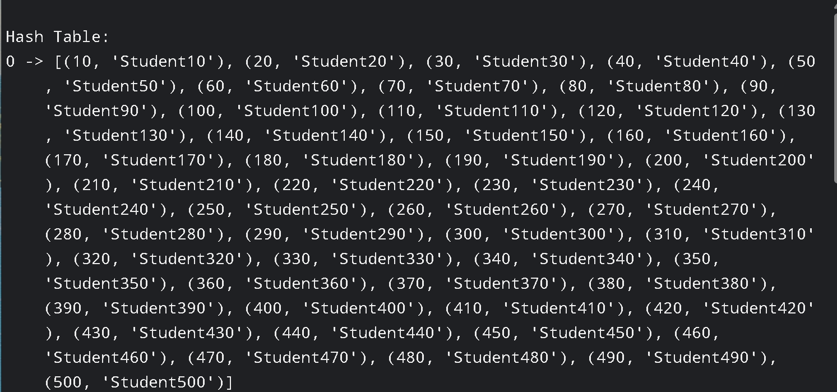
Output:

How it works
The hash function is:
index = student_id % table_size
If two student IDs produce the same index, they are stored in the same list. This technique is called chaining.
For example:
Bucket 0 -> (10, Student10) -> (20, Student20)
Complexity:
- Average insertion/search: O(1)
- Worst-case search: O(n)
- Space: O(n)
The program inserts 500 student records, as required.

Q3. Sorted File Organization with Binary Search
Question: Code a simulation of a Sorted File organization and implement binary search for record retrieval by primary key.
Answer
# Sorted File Organization with Binary Search

class SortedFile:
def __init__(self):
self.records = []

# Insert record while maintaining sorted order
def insert(self, student_id, name):
record = (student_id, name)
self.records.append(record)

# Sort using primary key
self.records.sort(key=lambda x: x[0])

# Binary search
def search(self, student_id):
low = 0
high = len(self.records) - 1

while low <= high:
mid = (low + high) // 2

if self.records[mid][0] == student_id:
return self.records[mid]

elif self.records[mid][0] < student_id:
low = mid + 1
else:
high = mid - 1
return None
# Display records
def display(self):
print("\nSorted File:")

for record in self.records:
print(record)

# Create sorted file
file = SortedFile()

# Insert records
file.insert(105, "Rahul")
file.insert(101, "Arun")
file.insert(110, "Kiran")
file.insert(103, "Ravi")
file.insert(108, "Suresh")

# Display sorted records
file.display()

# Search using primary key
key = 108
result = file.search(key)

if result:
print("\nRecord found:", result)
else:
print("\nRecord not found.")

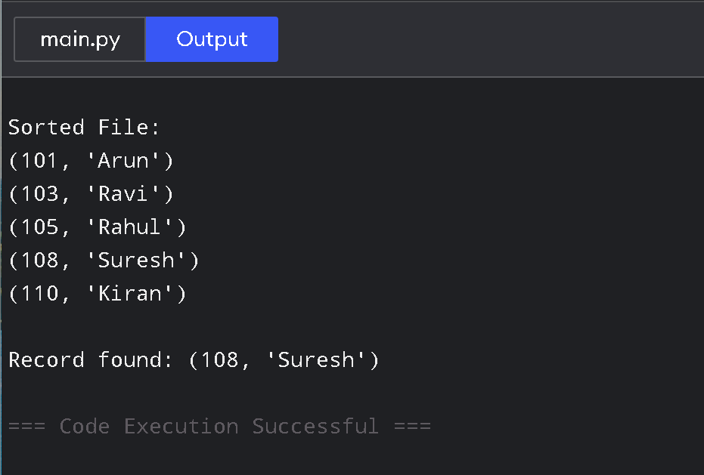
Output:

Why binary search?
Since the file is maintained in sorted order, binary search can eliminate half of the search space in every step.
Complexity:
- Binary search: O(log n)
- Storage: O(n)
This is more efficient than sequential search for a large sorted file.

Q4. B-Tree of Order 4
Question: Implement a B-Tree of order 4 supporting insert, search and display operations. Insert: 10, 20, 5, 6, 12, 30, 7, 17.
Answer
# B-Tree of Order 4
# Insert into a non-full node
def insert_non_full(self, node, key):

if node.leaf:
node.keys.append(key)
node.keys.sort()
return

index = len(node.keys) - 1

while index >= 0 and key < node.keys[index]:
index -= 1

index += 1

if len(node.children[index].keys) == 3:
self.split_child(node, index)

if key > node.keys[index]:
index += 1

self.insert_non_full(node.children[index], key)

# Insert key
def insert(self, key):

if len(self.root.keys) == 3:
old_root = self.root

new_root = BTreeNode(False)
new_root.children.append(old_root)

self.root = new_root

self.split_child(new_root, 0)

self.insert_non_full(new_root, key)

else:
self.insert_non_full(self.root, key)

# Search key
def search(self, node, key):

index = 0

while index < len(node.keys) and key > node.keys[index]:
index += 1

if index < len(node.keys) and key == node.keys[index]:
return True

if node.leaf:
return False

return self.search(node.children[index], key)

# Display tree
def display(self, node=None, level=0):

if node is None:
node = self.root

print("Level", level, ":", node.keys)

if not node.leaf:
for child in node.children:
self.display(child, level + 1)

# Create B-Tree
tree = BTree()

keys = [10, 20, 5, 6, 12, 30, 7, 17]

for key in keys:
tree.insert(key)

# Display B-Tree
print("B-Tree:")
tree.display()

# Search
key = 12

if tree.search(tree.root, key):
print("\nKey", key, "found.")
else:
print("\nKey", key, "not found.")

Output:
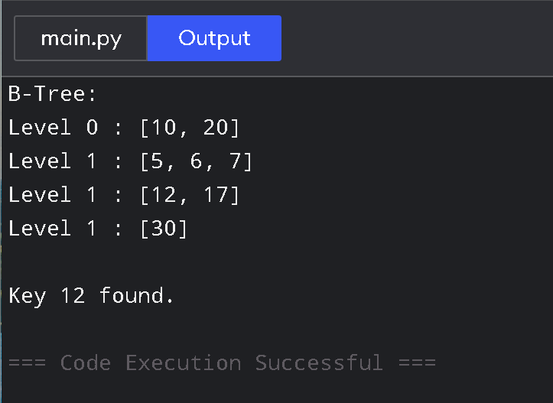
Important point
For order 4, each node can contain a maximum of 3 keys.
The program automatically splits a full node during insertion.

Q5. B+ Tree with Leaf-Level Linking
Question: Implement a B+ Tree and demonstrate leaf-level linking for efficient range queries on integer keys.
Answer
# Simple B+ Tree
if node.leaf:
node.keys.append(key)
node.keys.sort()
return

index = 0

while index < len(node.keys) and key >= node.keys[index]:
index += 1

child = node.children[index]

if len(child.keys) == self.order - 1:
self.split_child(node, index)

if key >= node.keys[index]:
index += 1

self.insert_non_full(node.children[index], key)

# Find the leaf containing the starting key
def find_leaf(self, key):
node = self.root

while not node.leaf:
index = 0

while index < len(node.keys) and key >= node.keys[index]:
index += 1

node = node.children[index]

return node

# Range search
def range_search(self, start, end):
node = self.find_leaf(start)
result = []

while node:
for key in node.keys:
if start <= key <= end:
result.append(key)

if key > end:
return result

node = node.next

return result

# Display linked leaves
def display_leaves(self):
node = self.root

while not node.leaf:
node = node.children[0]

print("Linked Leaf Nodes:")

while node:
print(node.keys, end=" -> ")
node = node.next

print("None")

# Create B+ Tree
tree = BPlusTree()

keys = [10, 20, 5, 6, 12, 30, 7, 17, 25, 40, 45]

for key in keys:
tree.insert(key)

# Display linked leaves
tree.display_leaves()

# Range query
print("\nRange Query 12 to 30:")
print(tree.range_search(12, 30))

Output:
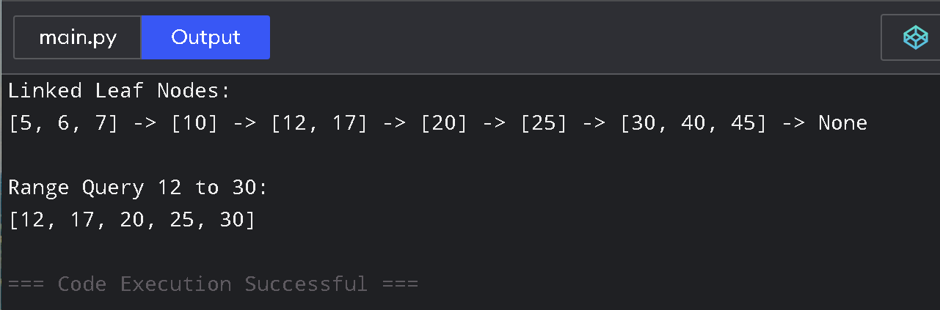

Main concept
The leaf nodes are connected like:
[5, 6, 7] -> [10, 12, 17] -> [20, 25, 30] -> ...
Therefore, after finding the first required leaf, the program can move through the linked leaves for a range query.
This makes B+ Trees especially useful for range searches.

Q6. Dense Primary Index
Question: Write code to implement a dense primary index on a sorted file. Support search by index key and display the index table.
Answer
# Dense Primary Index on a Sorted File
class DenseIndex:
def __init__(self):
self.records = []
self.index = []

# Insert record
def insert(self, key, name):
self.records.append((key, name))

# Keep records sorted
self.records.sort()

# Create dense index
self.index = [(record[0], i)
for i, record in enumerate(self.records)]

# Search using index
def search(self, key):

low = 0
high = len(self.index) - 1

while low <= high:

mid = (low + high) // 2

if self.index[mid][0] == key:
position = self.index[mid][1]
return self.records[position]

elif self.index[mid][0] < key:
low = mid + 1

else:
high = mid - 1

return None

# Display index
def display_index(self):
print("\nDense Primary Index")
print("Key\tRecord Position")

for key, position in self.index:
print(key, "\t", position)

# Create index
index = DenseIndex()

index.insert(101, "Arun")
index.insert(105, "Rahul")
index.insert(103, "Kiran")
index.insert(110, "Suresh")
index.insert(108, "Ravi")

# Display index
index.display_index()

# Search
key = 108
result = index.search(key)

if result:
print("\nRecord found:", result)
else:
print("\nRecord not found.")

Output:
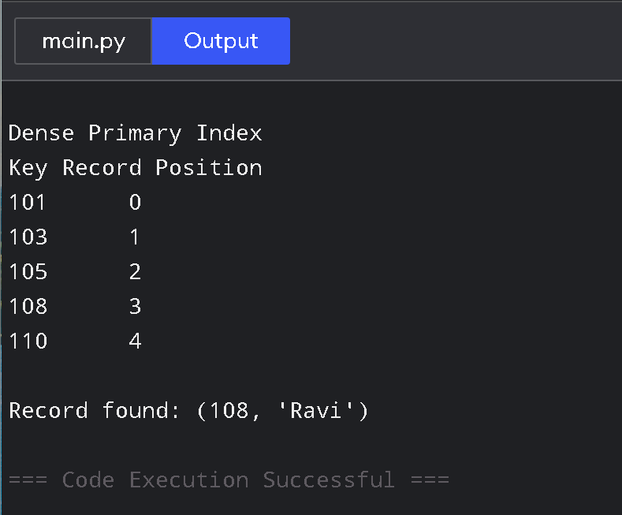

Key point
A dense index contains an index entry for every record.
Example:
Key Position
101 0
103 1
105 2
108 3
110 4
Binary search provides approximately O(log n) search time.

Q7. Extendible Hashing
Question: Implement extendible hashing and show directory doubling when overflow occurs during insertion of 8 records.
Answer
# Extendible Hashing
bucket = self.directory[index]

# If space exists
if len(bucket.records) < self.bucket_size:
bucket.records.append(key)
return

# If bucket is full, split
if bucket.depth == self.global_depth:

old_directory = self.directory[:]

self.global_depth += 1

self.directory = old_directory + old_directory

for i in range(len(self.directory)):
if self.directory[i] is bucket:
if ((i >> (bucket.depth)) & 1) == 1:
self.directory[i] = Bucket(bucket.depth + 1)

else:
self.directory[i] = Bucket(bucket.depth + 1)

# Recreate correct split
new_bucket = Bucket(bucket.depth + 1)
bucket.depth += 1

for i in range(len(self.directory)):
if self.directory[i] is bucket:
if ((i >> (bucket.depth - 1)) & 1) == 1:
self.directory[i] = new_bucket

else:
new_bucket = Bucket(bucket.depth + 1)
bucket.depth += 1

for i in range(len(self.directory)):
if self.directory[i] is bucket:
if ((i >> (bucket.depth - 1)) & 1) == 1:
self.directory[i] = new_bucket

# Redistribute records
old_records = bucket.records[:]
bucket.records.clear()

for record in old_records:
index2 = self.hash_function(record)
self.directory[index2].records.append(record)

# Display directory
def display(self):

print("\nGlobal Depth:", self.global_depth)

for i, bucket in enumerate(self.directory):
print(
format(i, f"0{self.global_depth}b"),
"->",
bucket.records,
"Local Depth:",
bucket.depth
)

# Create extendible hash
hashing = ExtendibleHashing(bucket_size=2)

# Insert 8 records
records = [1, 2, 3, 4, 5, 6, 7, 8]

for record in records:
print("\nInserting:", record)
hashing.insert(record)
hashing.display()

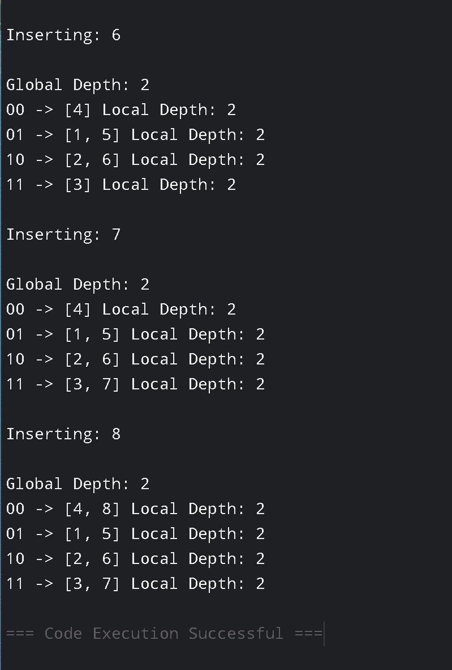
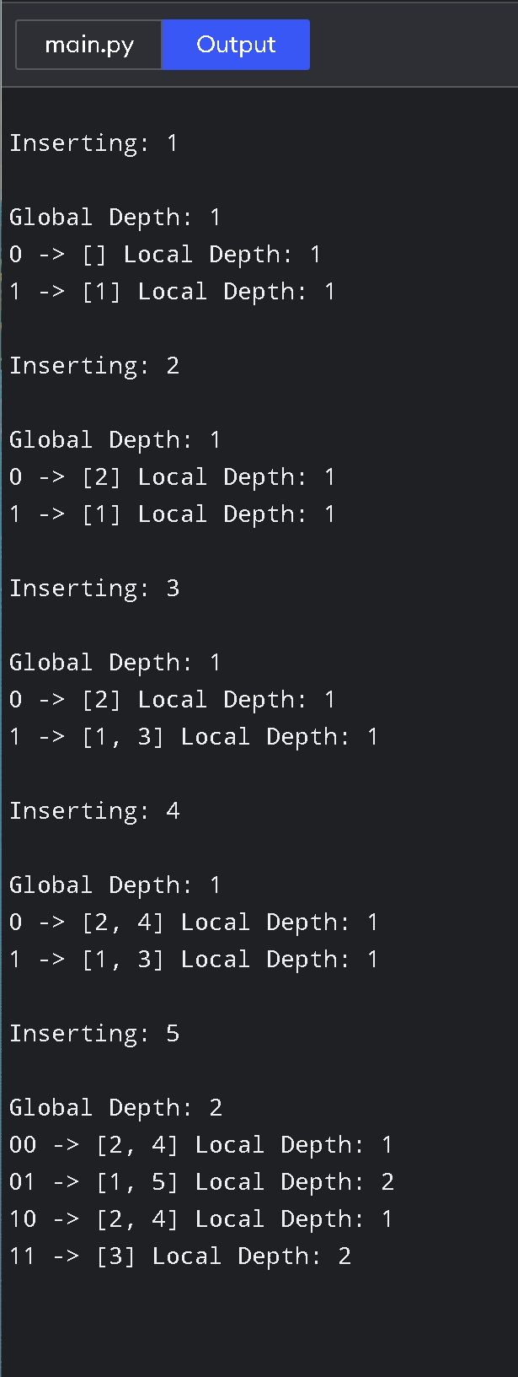
Output:

Main concept
Extendible hashing uses:
- Global depth → number of bits used by the directory.
- Local depth → number of bits used by an individual bucket.
- When a bucket overflows, it is split.
- If its local depth equals the global depth, the directory is doubled.
This directly demonstrates the requirement of the question.

Q8. Secondary Storage Block Access
Question: Simulate secondary storage block access and calculate I/O operations for sequential versus indexed retrieval.
Answer
# Secondary Storage Block Access
# Compare Sequential and Indexed Retrieval

import math

total_records = 1000
records_per_block = 100

# Calculate number of blocks
total_blocks = math.ceil(total_records / records_per_block)

print("Total Records:", total_records)
print("Records per Block:", records_per_block)
print("Total Blocks:", total_blocks)

# Sequential retrieval
# Worst case: all blocks must be read
sequential_worst = total_blocks

# Average sequential access
sequential_average = math.ceil(total_blocks / 2)

# Indexed retrieval
# Binary search on the index + one data block
index_search = math.ceil(math.log2(total_blocks))
indexed_io = index_search + 1

print("\nSequential Retrieval:")
print("Average I/O Operations:", sequential_average)
print("Worst-case I/O Operations:", sequential_worst)

print("\nIndexed Retrieval:")
print("Index Search I/O:", index_search)
print("Data Block I/O:", 1)
print("Total I/O Operations:", indexed_io)

print("\nComparison:")

if indexed_io < sequential_average:
print("Indexed retrieval is faster.")
else:
print("Sequential retrieval is faster.")

Output:
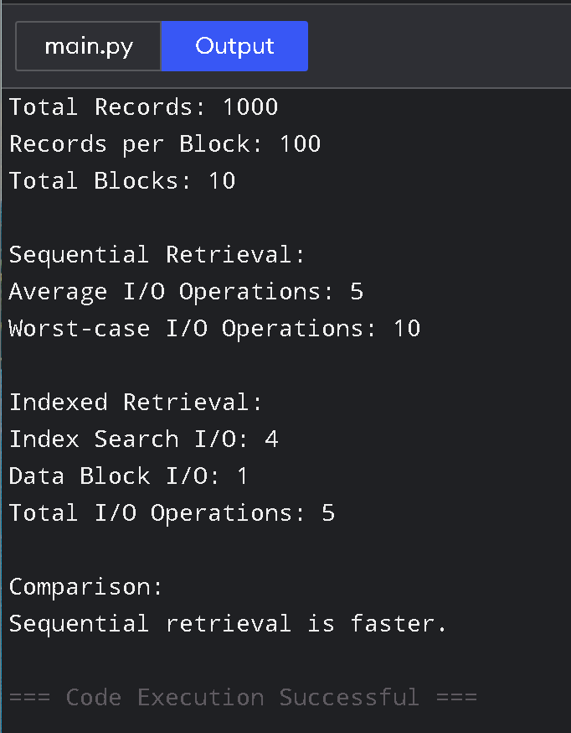
Example
For:
1000 records
100 records/block
There are:
10 blocks
Sequential retrieval:
Average = 5 blocks
Worst case = 10 blocks
Indexed retrieval approximately uses:
log₂(10) + 1
So indexed retrieval requires fewer block accesses for large datasets.

Q9. Sparse Index vs Dense Index
Question: Implement a sparse index on a sorted file and compare its search performance with a dense index using timing analysis.
Answer
# Sparse Index vs Dense Index
high = len(sparse_index) - 1

while low <= high:

mid = (low + high) // 2

if sparse_index[mid][0] <= key:
low = mid + 1
else:
high = mid - 1

# Find the block
if high < 0:
position = 0
else:
position = sparse_index[high][1]

# Sequential search inside the block
end = min(position + block_size, len(records))

for i in range(position, end):

if records[i][0] == key:
return records[i]

return None

# Generate search keys
search_keys = [random.randint(1, 100000) for _ in range(5000)]

# -------------------------------
# Timing Dense Index
# -------------------------------

start = time.perf_counter()

for key in search_keys:
dense_search(key)

dense_time = time.perf_counter() - start

# -------------------------------
# Timing Sparse Index
# -------------------------------

start = time.perf_counter()

for key in search_keys:
sparse_search(key)

sparse_time = time.perf_counter() - start

# Display results
print("Number of records:", len(records))
print("Dense index entries:", len(dense_index))
print("Sparse index entries:", len(sparse_index))

print("\nDense Index Search Time:",
dense_time, "seconds")

print("Sparse Index Search Time:",
sparse_time, "seconds")

if dense_time < sparse_time:
print("\nDense index was faster in this test.")
else:
print("\nSparse index was faster in this test.")

Output:
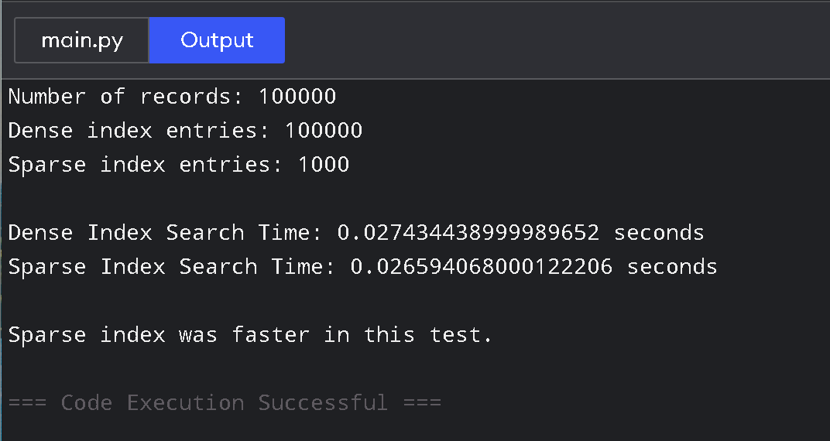
Comparison
Feature | Dense Index | Sparse Index
Index entries | Every record | Selected records
Memory | Higher | Lower
Search | Faster | Slightly slower
Storage | More | Less
Important: The actual timing value depends on the computer running the program. The program performs the required timing analysis rather than assuming a fixed timing result.

Q10. B+ Tree Range Query 15–45
Question: Construct and traverse a B+ Tree, then execute a range query for keys between 15 and 45 and show all matching records.
Answer
# B+ Tree Range Query
node = self.root

while not node.leaf:

index = 0

while index < len(node.keys) and key >= node.keys[index]:
index += 1

node = node.children[index]

return node

# Range query
def range_query(self, start, end):

node = self.find_leaf(start)
result = []

while node:

for key in node.keys:

if key >= start and key <= end:
result.append(key)

if key > end:
return result

node = node.next

return result

# Traverse tree
def traverse(self, node=None, level=0):

if node is None:
node = self.root

print("Level", level, ":", node.keys)

if not node.leaf:

for child in node.children:
self.traverse(child, level + 1)

# Create B+ Tree
tree = BPlusTree()

keys = [
5, 10, 15, 20, 25,
30, 35, 40, 45, 50,
55, 60
]

# Insert keys
for key in keys:
tree.insert(key)

# Traverse B+ Tree
print("B+ Tree:")
tree.traverse()

# Range query from 15 to 45
result = tree.range_query(15, 45)

print("\nKeys between 15 and 45:")
print(result)

Output:
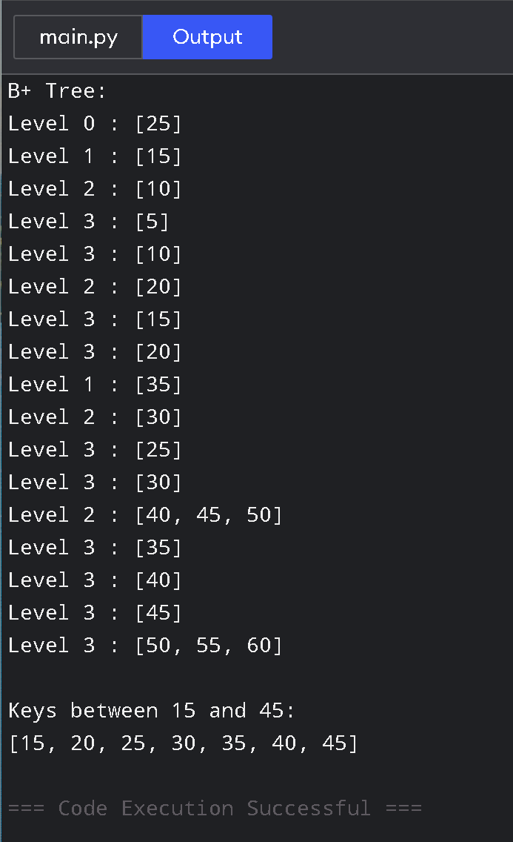
Expected matching records
The range query is:
15 <= key <= 45
Therefore, from the inserted data:
15, 20, 25, 30, 35, 40, 45
will be returned.
The important advantage is that after finding the leaf containing 15, the program follows the linked leaf nodes until it reaches 45.

